A000-US-OH-Birdstone-Banded Slate-Glacial Kame Culture - 8000-1000 BCE.

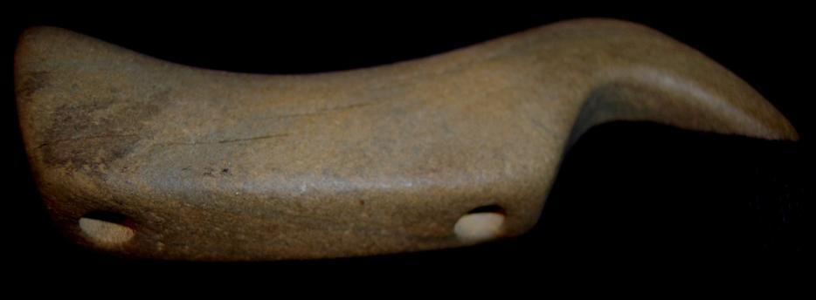 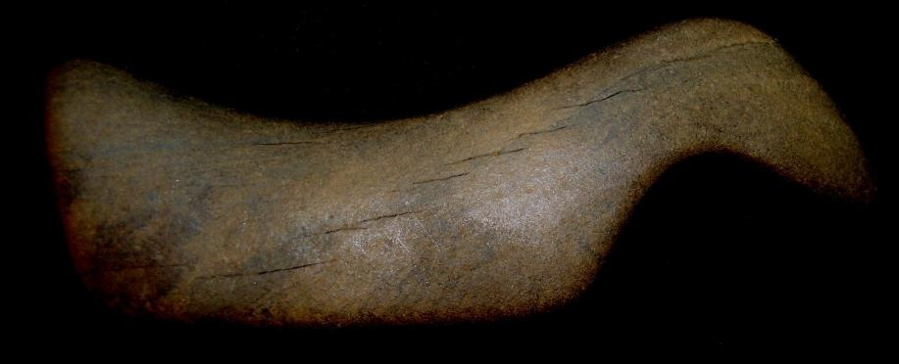

SHAPE \* MERGEFORMAT 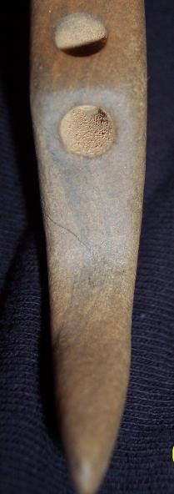

US- US-OH-Birdstone-Banded Slate-Glacial Kame Culture - 8000-1000 BCE..

4.25 in. length

Case no.: 11

Accession Number:

Formal Label: US-OH-Birdstone-Banded Slate-Glacial Kame Culture - 8000-1000 BCE.

**Display Description:**

This birdstone was found with a Glacial Kame burial in northwestern Ohio, county unknown. In the drilled holes and coatint the exterior surface there is h a brown patina from mineralization. The name of this culture derives from its members' practice of burying their dead atop glacier-deposited gravel hills. Among the most common types of artifacts found at Glacial Kame sites are shells of marine animals and goods manufactured without smelting from float copper ore that was regularly deposited after severe winters from being floated on the ice and driven by wind to the banks of the Great Lakes..

**LC Classification:**

Date or Time Horizon: Glacial Kame Culture - 8000-1000 BCE Geographical Area: Glacial Kame Culture, Northwestern OH

**Map:**

**GPS coordinates:**

Cultural Affiliation: Glacial Kame Culture, Northwestern OH

Medium: banded slate

Dimensions: L 4.25 in

Weight:

Condition:

Provenance: . N.E. Carter of Wisconsin collected it in the late 1800’s and then it is believed that it went to the Ringheisen collection at Milwaukee in the early 1900s.

**Discussion:**

The type site for Glacial Kame is the Ridgeway Site near the village of [Ridgeway](https://en.wikipedia.org/wiki/Ridgeway,_Ohio) in [Hardin County, Ohio](https://en.wikipedia.org/wiki/Hardin_County,_Ohio). The site was discovered in 1856 by workers building a railroad line nearby, who mined the kame for [ballast](https://en.wikipedia.org/wiki/Track_ballast); the supervisor's detailed report of the excavation has survived to the present day and is a premier resource for the culture (Cunningham 1948).

**References:**

Cunningham, Wilbur M. 1948. *A Study of the Glacial Kame Culture in Michigan, Ohio, and Indiana*. Occasional Contributions from the Museum of Anthropology of the University of Michigan 12. [Ann Arbor](https://en.wikipedia.org/wiki/Ann_Arbor,_Michigan): Universityress

|  |
| --- |
| **Ralph J Coffman Jr**  149 Atlantic Ave  Swampscott MA 01907-2427  United States |

## Order details

|  |  |  |  |  |  |
| --- | --- | --- | --- | --- | --- |
|  | **Item title** | | **Available actions** | **Shipping & handling (estimated delivery*)** | **Price** |
| Seller: | | [**Member id** clovisconnection](http://myworld.ebay.com/clovisconnection) ( [**Feedback Score Of** 3929](http://feedback.ebay.com/ws/eBayISAPI.dll?ViewFeedback&userid=clovisconnection)) | | [Contact seller](http://contact.ebay.com/ws/eBayISAPI.dll?ShowCoreAskSellerQuestion&frm=3998&iid=380490658111&redirect=0&requested=clovisconnection) |  |

|  |  |  |  |  |
| --- | --- | --- | --- | --- |
| Paid on Oct-23-12 via PayPal | | | | |
|  |  |  |  |  |

|  |  |  |  |  |  |  |  |
| --- | --- | --- | --- | --- | --- | --- | --- |
| [**Item Title:**4 1/4"-BIRDSTONE-ARROWHEAD- ARTIFACT REPRO-ARROWHEADS-DRILLED**- opens in a new window or tab**](http://cgi.ebay.com/ws/eBayISAPI.dll?ViewItem&item=380490658111)  **Item Id:**380490658111 - Price: US $24.99  Quantity:1  Having a problem with this purchase? [We can help](javascript:;) | |  | | --- | |  | | |  |  | | --- | --- | | [Leave feedback](http://feedback.ebay.com/ws/eBayISAPI.dll?LeaveFeedbackShow&useridfrom=802-867&useridto=clovisconnection&item=380490658111&transactid=0) |  | | | Expedited Shipping : **US $6.00**  USPS Priority Mail®  Estimated delivery on or before Sat. Oct. 27  **Package 1 of 1**    Shipment details: [03121430000164217029](javascript:;) | US $24.99 |



**Payment Instructions:**

PayPal is quickest!

|  |  |
| --- | --- |
|  |  |